Knowledge Organiser Key Stage 3

Subject : Science Year: 7 Topic Title: Chemical Reactions

Key Facts
- Features of a chemical change include a colour change, temperature change, sparks or flames and gas is made.
- The periodic table is an arrangement of all the elements.
- When equal volumes of acids and alkalis are added together a neutralisation reaction occurs.
- On the pH scale: 1 to 6 is an acid, 7 is neutral and 8-14 are alkali.
- Acidic solutions form when acids dissolve in water.
- Alkaline solutions form when alkalis dissolve in water.
- Solutions that are neither acidic nor alkaline are neutral.
- Universal indicator can tell us how strong acidic or alkaline a solution is.
- The closer to pH 0 you go, the more strongly acidic it is.
- The closer to pH 14 you go, the more strongly alkaline it is.
- Reactants are reacted together (e.g. iron and sulphur).
- Products are formed in the reaction (e.g. iron sulphide).
- The name of a salt has two parts; the first part comes from the metal in the alkali used, the second part comes from the acid that was used.
- When hydrochloric acid is used the second part of the salt is called chloride.
- When sulfuric acid is used the second part of the salt is called sulfate.
- When nitric acid is used the second part of the salt is called nitrate
- Total mass of the reactants = Total mass of the products

Key words
- An atom is the smallest part of a chemical that can exist.
- Reactants are the chemicals we react together.
- Products are what is produced after the reaction has taken place.
- An element is a substance that cannot be broken down into any other substance, for example gold.
- Concentration How many particles are dissolved in a solution
- Combustion is the burning of a fuel in oxygen
- Acid a substance with a pH below 7
- Alkalis a substance with a pH above 7
- Neutral a substance with a Ph of 7
- Hazard is any substance or item that could be dangerous
- Corrosive any substance that can eat through materials
- Hypothesis is a statement that can be tested scientifically

Diagrams

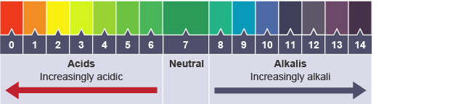

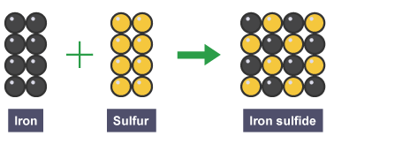

Potential misconceptions to avoid / errors students often make
- Energy cannot be ‘given off’ (or created, or destroyed) only transferred.
- Equations should be written with an arrow not an equal sign.
- ‘Squeaky pop’ is not the test for hydrogen. To test for hydrogen put a lit splint into the gas, if there is a squeaky pop then there is hydrogen present.
- Do not use the word amount, it is mass (for solids) or volume (for liquids).

